Please CAREFULLY read the questions and follow instructions to answer.

Problem 1. Try to insert a USB stick into your computer, then find whether it has been automatically mounted on somewhere in the file tree by 'diff'. If so, then try to unmount it manually from the file tree. After that, try to mount the USB stick to your home directory.

Problem 2. Try to enter shell as superuser (with great care). Try to change the hostname of your computer and keep this new name after restarting computer. Clues might be found from the web, but do make sure everything before doing this experiment.

Hostname

Hostnamectl

查看主机名

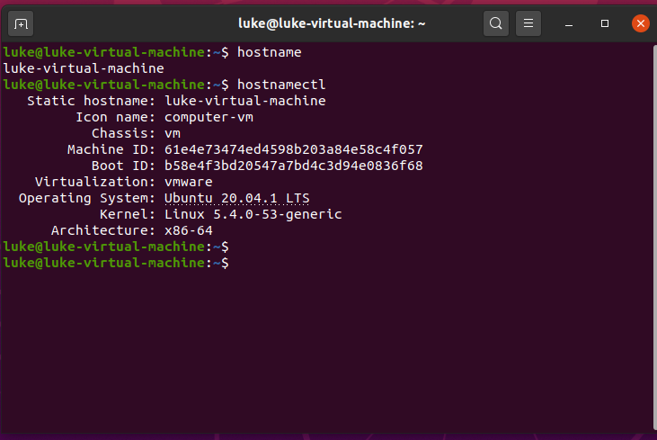

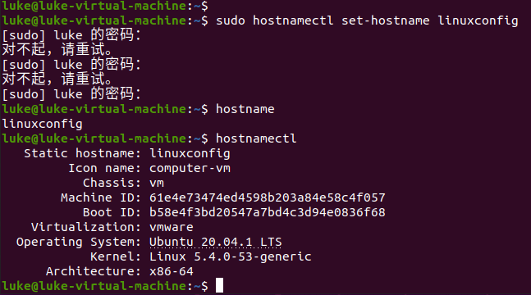

sudo hostnamectl set-hostname linuxconfig

问题1: bash: /etc/hosts: 权限不够

因为现在不是root权限所以不能修改，要通过su进入到root权限中。这时就可以以root身份进行chmod命令操作。

 edit the file to reflect the change

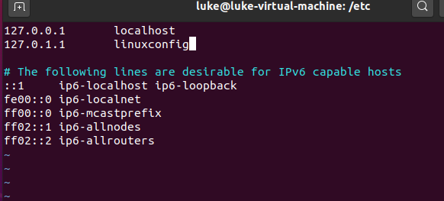

重启后也可以



Problem 3. Ask your friend to build demo_x.c (installing X11 development library first) and change the umbrella to another icon (hourglass?), then try to remotely enter your friend's computer by ssh, display this program on your own computer's screen, along with(与……一起；伴随；和…一起) your local umbrella version program. Post a video clip to our Wechat group.

服务器的ssh 登录 ssh -p 11189 root@117.93.33.92

然后我要把demo_x.c传输上去. 然后修改,然后display一下就可以了.

用法: scp -r demo_x.c root@117.93.33.92:/home/data/

Scp是先ssh才能用吗? 还是不登录直接在本地scp就可以?

答: 本地scp就可以了,注意要指定端口 ,否则会超时.

scp -P 11189 -r demo_x.c [root@117.93.33.92:/home/data](mailto:root@117.93.33.92:/home/data)

上传成功!

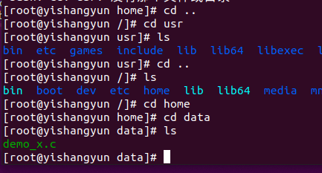

CentOS 下载库yum install -y xorg-x11-xauth

软件包 1:xorg-x11-xauth-1.0.9-1.el7.x86_64 已安装并且是最新版本

错误1 : gcc demo_x.c

/tmp/ccXL4Fia.o：在函数‘main’中：

demo_x.c:(.text+0x1e)：对‘XOpenDisplay’未定义的引用

解决方法: gcc -o main demo_x.c -lX11试试 –l X11就可以了

./a.out

错误2: can't open display

因为这是个服务器没有界面

可以看这个来执行:

<https://www.cnblogs.com/tsfh/p/9022170.html>

试试时钟?

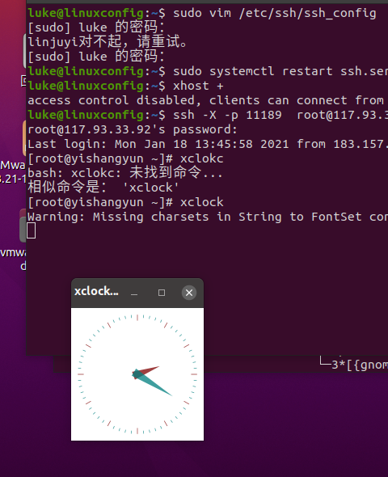

成功!

修改

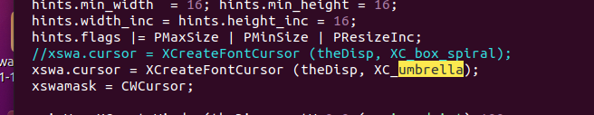

即可. 显示成功!

室友的ip地址~$ ssh brine@192.168.43.190

问题1 : ssh: connect to host 192.168.43.190 port 22: Connection refused

解决方法:   
1.确定安装sshd:

$ sudo apt get install openssh-server

2.启动sshd:

$ sudo net start sshd

3.检查防火墙设置,关闭防火墙：

$ sudo ufw disable

检验方法：首先用下面的命令查看了防火墙的状态，发现防火墙已经关闭了：

parallels@ubuntu:~$ sudo ufw status  
状态：不活动  
输入命令：$ ssh localhost

若成功，则表示安装成功，且连接通过；

ssh localhost

luke@localhost's password:

Welcome to Ubuntu 20.04.1 LTS (GNU/Linux 5.4.0-53-generic x86_64)

82 updates can be installed immediately.

0 of these updates are security updates.

To see these additional updates run: apt list --upgradable

Your Hardware Enablement Stack (HWE) is supported until April 2025.

Last login: Sun Jan 17 22:45:03 2021 from 127.0.0.1

问题2: 虚拟机上网好像有点问题, ssh自己可以的, ping百度也可以的. 但是ssh室友的还是会refuse ssh: Could not resolve hostname

解决方法:

j27583366l.zicp.vip:39还要说明的是，SSH服务的**默认端口是22**，也就是说，如果你不设置端口的话登录请求会自动送到远程主机的22端口。我们可以使用**-p 选项来修改端口号**，比如连接到服务器的1234端口：256: Name or service not known

ssh -p 1234 ldz@192.168.0.1

Problem 4. Find a file makefile.bit from our demo code bundle. Read it and find other two related source files. Try to make and get the resulted executable to run. Explain the command line usage and the purpose of the result program.

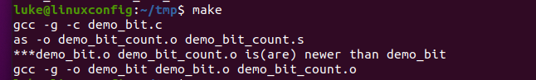

the purpose of the result program. : turn the input into hexadecimal number

and count how many bits of this number is 1;

Problem 5. 1) Download cube_wrong.tar from a github address, check its contents, extract it, make it and execute (all actions must be in text mode).

需要x11库sudo apt-get install libghc-x11-dev

Make

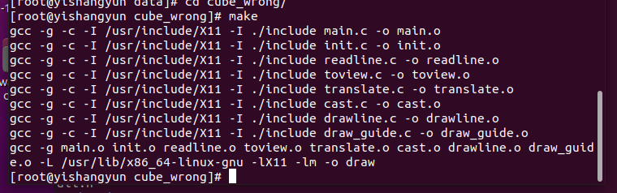

执行:

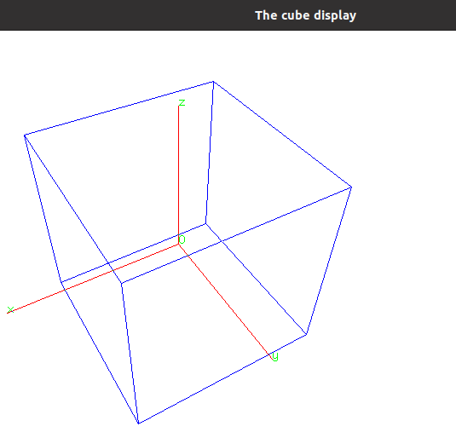

# 删除软件及其配置文件

apt-get --purge remove <package>

# 删除没用的依赖包

apt-get autoremove <package>

# 此时dpkg的列表中有“rc”状态的软件包，可以执行如下命令做最后清理：

dpkg -l |grep ^rc|awk '{print $2}' |sudo xargs dpkg –P

2) Find the reasons for compiling warnings, and remove them.

3) (OPTIONAL) Compare the running result with screenshot_cube_correct.png, and then try to find hidden bugs by running gdb/ddd. Take a screenshot too whether you fix all bugs or not; however if bugs are fixed, the screenshot should include the modified code.